Database Systems Lab - 14CS2012

REGISTER NO: UR14CS228
DATE: 11-08-16
EXPERIMENT NO-1

Video URL: https://youtu.be/1hfrKDK9kCs?list=PLRS_VYrnFL6lj53kJl8EaWDEsoE-8Epkj

AIM:
Create tables using DDL and DCL commands.
DESCRIPTION:
Data Definition Language (DDL) - These SQL commands are used for creating, modifying, and dropping the structure of database objects. The commands are CREATE, ALTER, DROP, RENAME, and TRUNCATE.

Data Control Language (DCL) - These SQL commands are used for providing security to database objects. These commands are GRANT and REVOKE.

1.Create the above tables, with primary key constraints.
2.Add foreign key reference to the customer_id attribute.

CREATE TABLE customer(customer_id NUMBER(10),customer_name
VARCHAR(25),customer_address VARCHAR(50),city VARCHAR(10),state
VARCHAR(20),pstal_code VARCHAR(6),CONSTRAINT pk_customerid PRIMARY KEY (customer_id));
DESC customer;
CREATE TABLE orders(order_id NUMBER(10),order_date DATE,customer_id NUMBER(10),CONSTRAINT pk_orderid PRIMARY KEY (order_id),CONSTRAINT fk_orderid FOREIGN KEY (customer_id) REFERENCES customer(customer_id));
DESCorders;
CREATE TABLE product(product_id NUMBER(10),product_description
VARCHAR(50),product_finish VARCHAR(10),product_line_id NUMBER(10),CONSTRAINT pk_productid PRIMARY KEY (product_id));
DESC product;
CREATE TABLE orderline(order_id NUMBER(10),product_id NUMBER(10),ordered_quantity
NUMBER(10),CONSTRAINT pk_orderid1 PRIMARY KEY (order_id),FOREIGN KEY (product_id) REFERENCES product(product_id));
DESC orderline;
CREATE TABLE supplier(s_id NUMBER(10),s_name VARCHAR(25),gender
VARCHAR(8),s_date DATE,p_id NUMBER(10),CONSTRAINT pk_sid PRIMARYKEY(s_id));
DESC supplier;
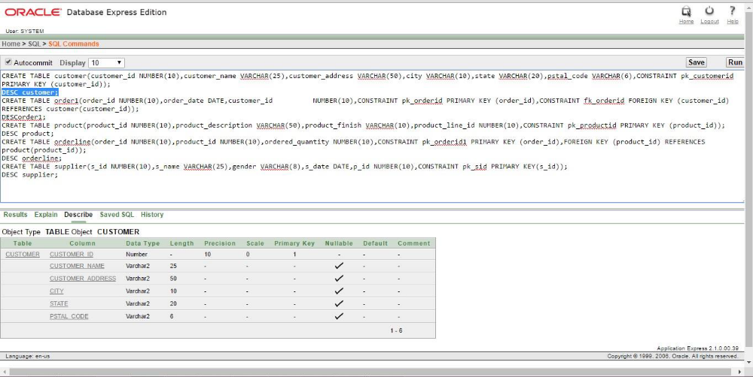
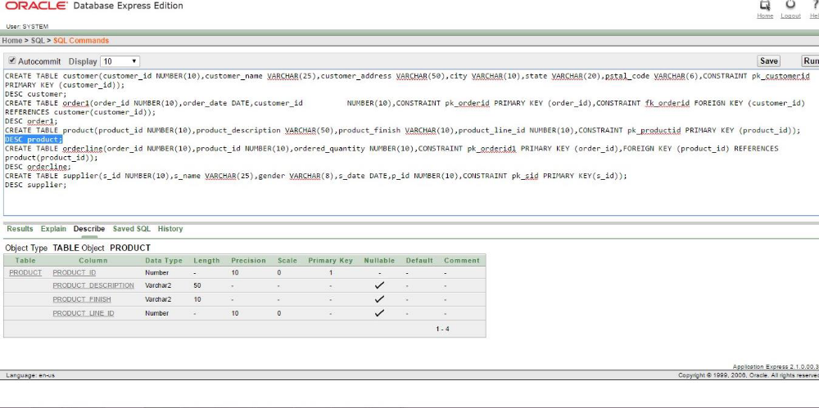
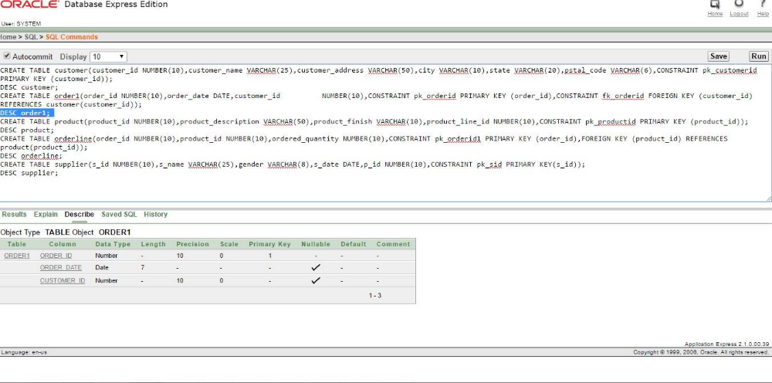
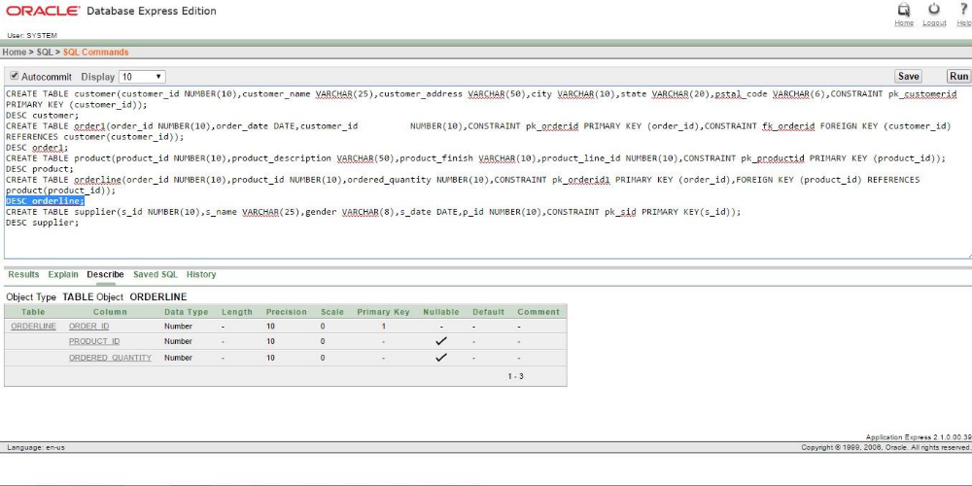
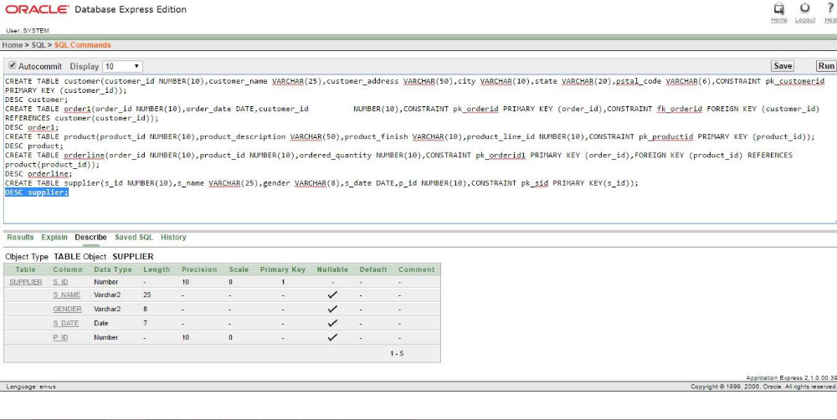

3.Modify the attribute product_finish in the product table to product_material.
ALTER TABLE product RENAME COLUMN product_finish TO product_material;
DESC product;
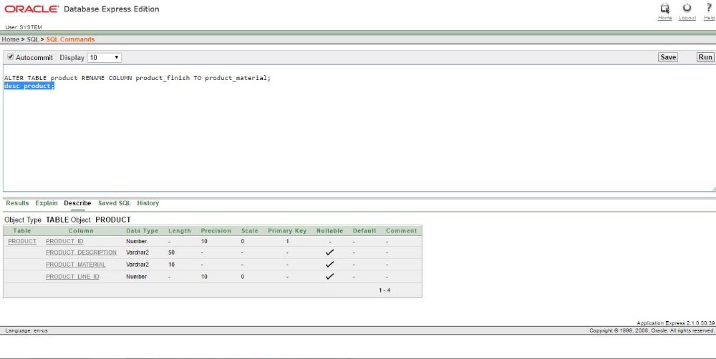
4.Add an attribute called price in the Orderline table
ALTER TABLE orderline ADD price NUMBER(10);
Desc orderline;
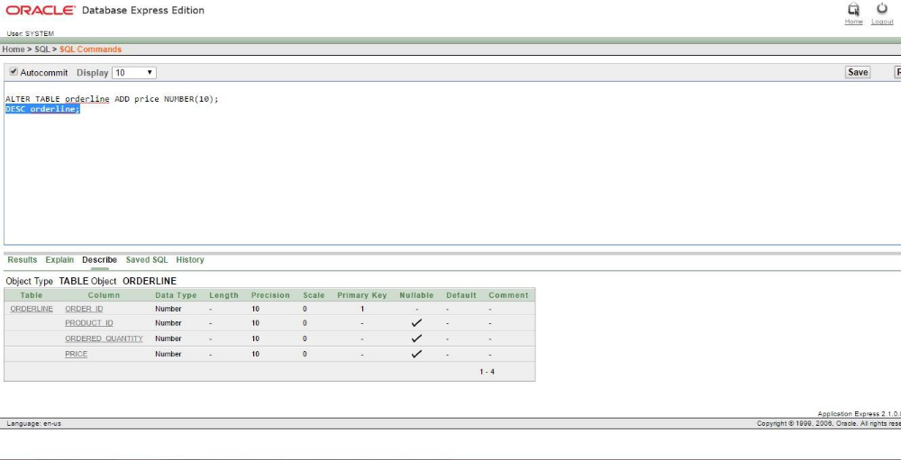

5.Rename orderline to orderquantity
ALTER TABLE orderline RENAME TO orderquantity;
DESC orderquantity;
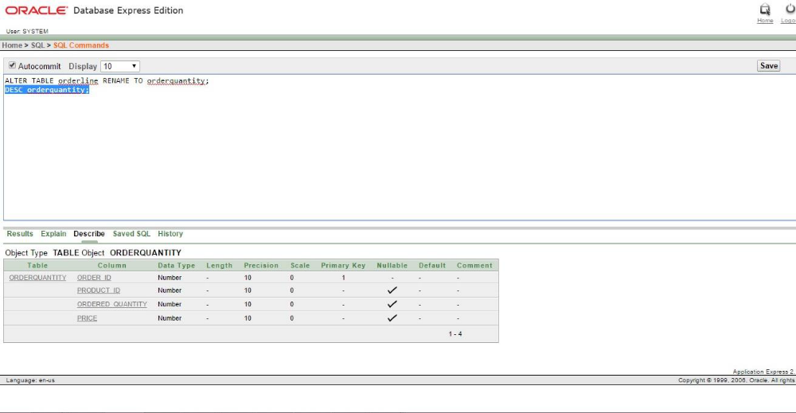
6.Add a check constraint to ordered_quantity column and check that quantity is above 10
ALTER TABLE orderquantity ADD CONSTRAINT chk_orderedquantity CHECK(ordered_quantity>10);
DESC orderquantity;

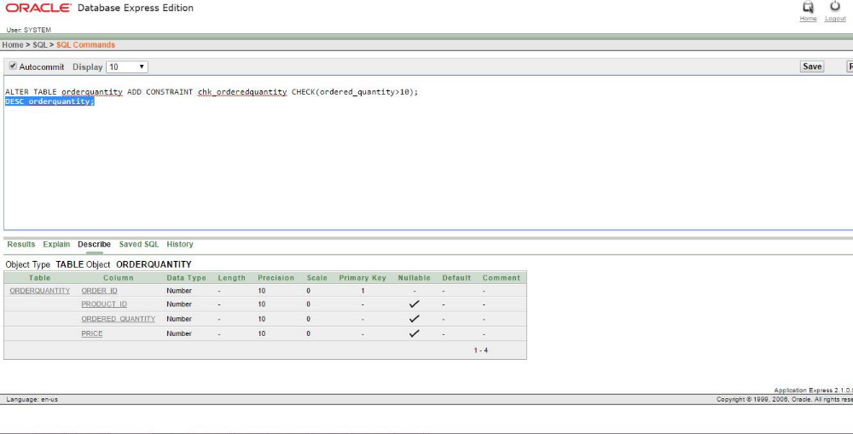

7.Add a not null constraint to customer_name attribute.
ALTER TABLE customer MODIFY customer_name NOT NULL; DESC customer;

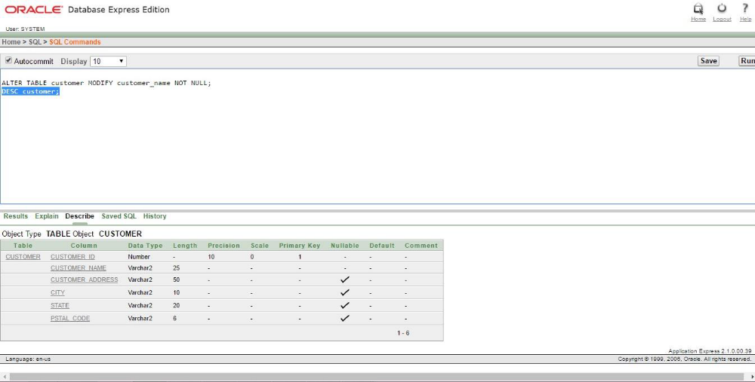

8. the structure of the customer and order table
DESC customer;
DESC orders;

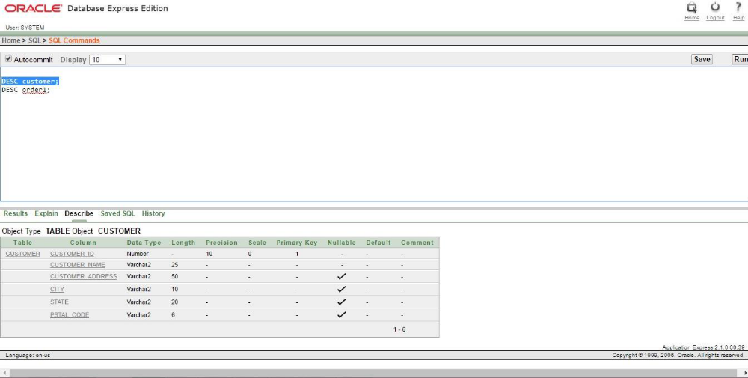

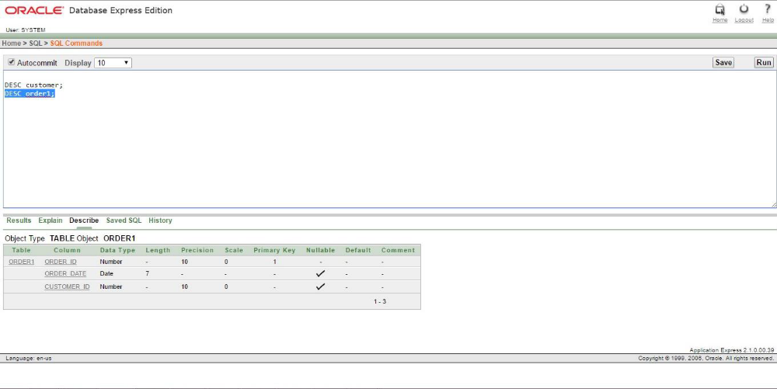

9.Insert the above values in to the corresponding table.
INSERT INTO customer VALUES (1, 'John Doe', '392 Sunset Blvd.', 'New York', 'NT','10059');
INSERT INTO customer VALUES (2, 'Mary Smith', '6900 Main St.', 'SanFrancis', 'CA','94032');
INSERT INTO customer VALUES (3, 'Richard Newman', '2040 Riverside Rd.', 'San Diego', 'CA','92010');
INSERT INTO customer VALUES (4, 'Cathy Cook', '4010 Speedway', 'Tucson', 'AZ','85719');
INSERT INTO orders VALUES (100,TO_DATE('01-OCT-2014','DD-MONYYYY'),1);
INSERT INTO orders VALUES (101, TO_DATE('01-OCT-2014','DD-MON-YYYY'),
2);
INSERT INTO orders VALUES (102, TO_DATE('02-OCT-2014','DD-MON-YYYY'),
3);
INSERT INTO orders VALUES (103, TO_DATE('03-OCT-2014','DD-MON-YYYY'),
2);
INSERT INTO orders VALUES (104, TO_DATE('10-OCT-2014','DD-MON-YYYY'),
1);
INSERT INTO orders VALUES (105, TO_DATE('10-OCT-2014','DD-MON-YYYY'),
4);
INSERT INTO orders VALUES (106, TO_DATE('10-OCT-2014','DD-MON-YYYY'),
2);
INSERT INTO orders VALUES (107,TO_DATE('10-OCT-2014','DD-MON-YYYY'),
1);
INSERT INTO
product(product_id,product_description,product_material,product_line_id)VALUES (1000, 'Office Desk', 'Cherry',10);
INSERT INTO
product(product_id,product_description,product_material,product_line_id)VALUES (1001, 'Manager''s Desk', 'Red Oak',10);
INSERT INTO
product(product_id,product_description,product_material,product_line_id)VALUES (2000, 'Office Chair', 'Cherry',20);
INSERT INTO
product(product_id,product_description,product_material,product_line_id)VALUES (2001, 'Manager''s Desk', 'NaturalOak',20);
INSERT INTO
product(product_id,product_description,product_material,product_line_id)VALUES (3000, 'Book Shelf', 'NaturalAsh',30);
INSERT INTO
product(product_id,product_description,product_material,product_line_id)VALUES (3001, 'Duplex Book Shelf', 'White Ash',30);
INSERT INTO
product(product_id,product_description,product_material,product_line_id)VALUES (4000, 'Table Lamp', 'NaturalAsh',40);
INSERT INTO
product(product_id,product_description,product_material,product_line_id)VALUES (4001, 'Duplex Table Lamp', 'White Ash',40);
INSERT INTO
product(product_id,product_description,product_material,product_line_id)VALUES (9999, 'Keyboard', 'Plastic',50);
INSERT INTO orderquantity VALUES (100, 4000, 10, 10000);
INSERT INTO orderquantity VALUES (101, 1000, 20, 15000);
INSERT INTO orderquantity VALUES (101, 2000, 20, 20000);
INSERT INTO orderquantity VALUES (102, 3000, 15, 23500); INSERT INTO orderquantity VALUES (102, 2000, 12, 34560);
INSERT INTO orderquantity VALUES (103, 4001, 14, 1000);
INSERT INTO orderquantity VALUES (104, 2000, 10, 2000);
INSERT INTO orderquantity VALUES (105, 3001, 20, 30005);
INSERT INTO orderquantity VALUES (106, 3000, 12, 20500);
INSERT INTO orderquantity VALUES (106, 4000, 11, 30000);
INSERT INTO orderquantity VALUES (107, 4001, 5, 40100);
INSERT INTO supplier VALUES (1,'aaa','M' ,TO_DATE('11-NOV-2014','DD-MONYYYY'),1000);
INSERT INTO supplier VALUES (2, 'bbb', 'F',TO_DATE('01-NOV-2014','DD-MONYYYY'), 2000);
INSERT INTO supplier VALUES (2, 'bbb', 'F',TO_DATE('01-NOV-2014','DD-MONYYYY'), 2001);
INSERT INTO supplier VALUES (3,'ccc','M',TO_DATE('20-OCT-2014','DD-MONYYYY'),9999);
INSERT INTO supplier VALUES (4,'ddd','F',TO_DATE('11-NOV-2014','DD-MONYYYY'),4001);
INSERT INTO supplier VALUES (4, 'ddd', 'F',TO_DATE('05-NOV-2014','DD-MONYYYY'), 4000);
INSERT INTO supplier VALUES (5, 'eee','M',TO_DATE('13-NOV-2014','DD-MONYYYY'), 1001);

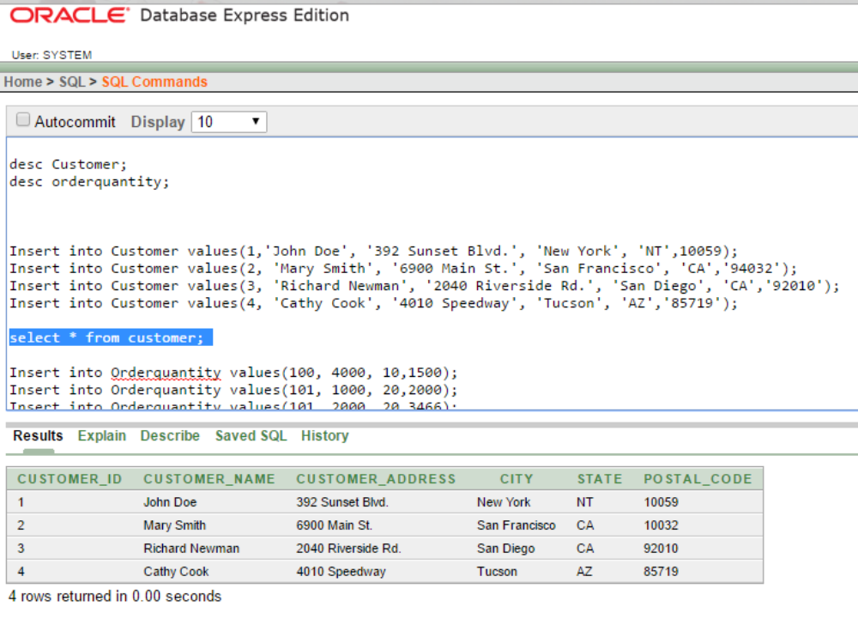

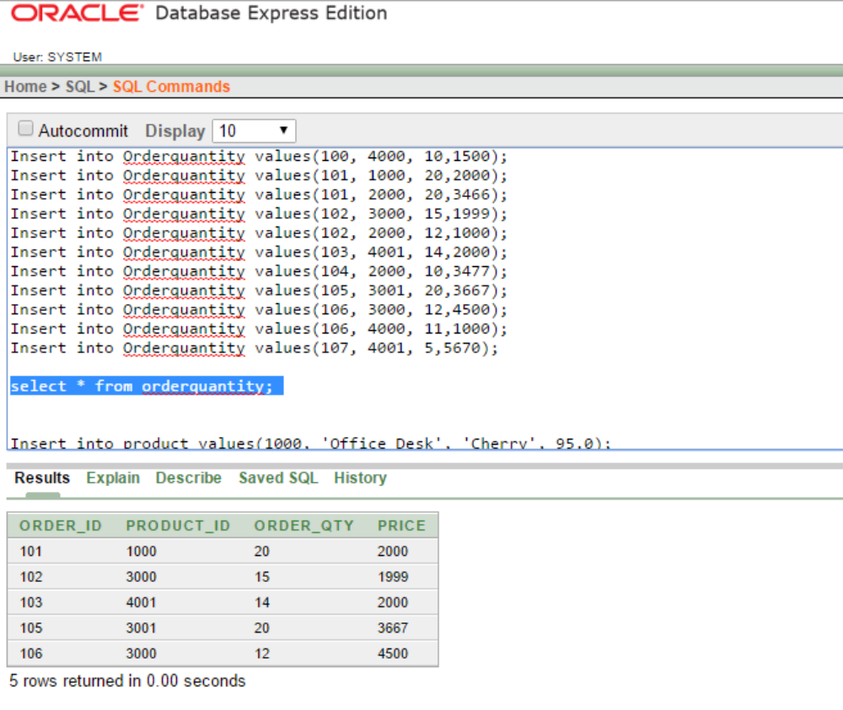
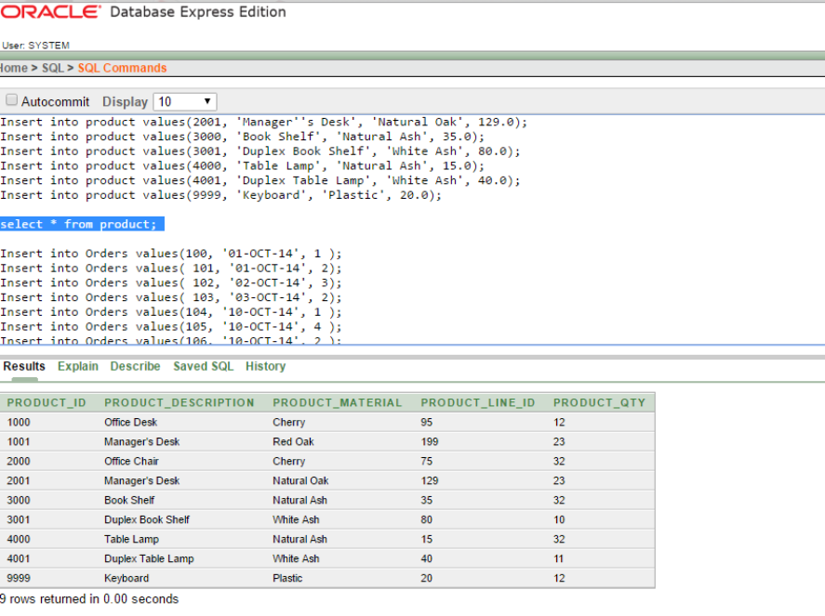

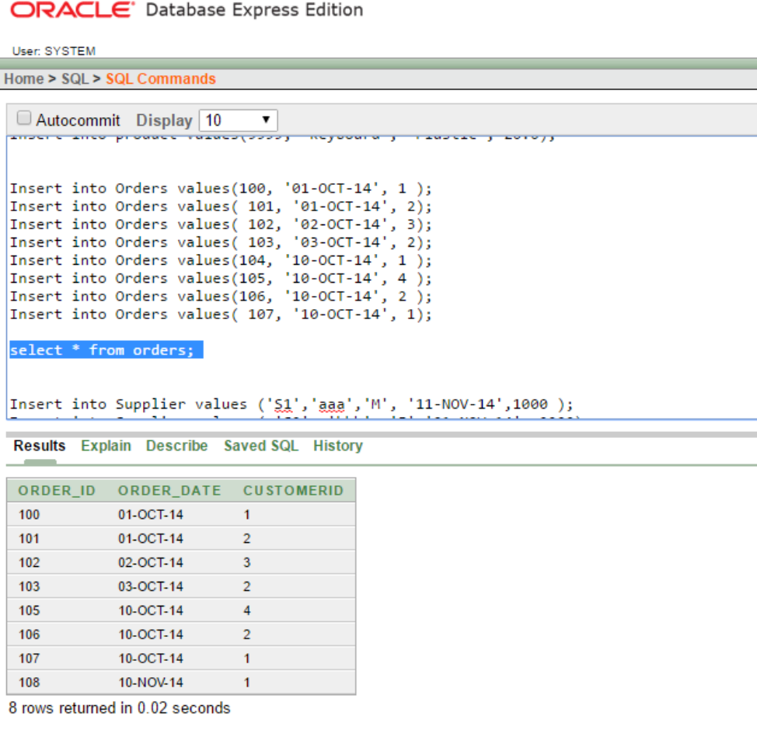
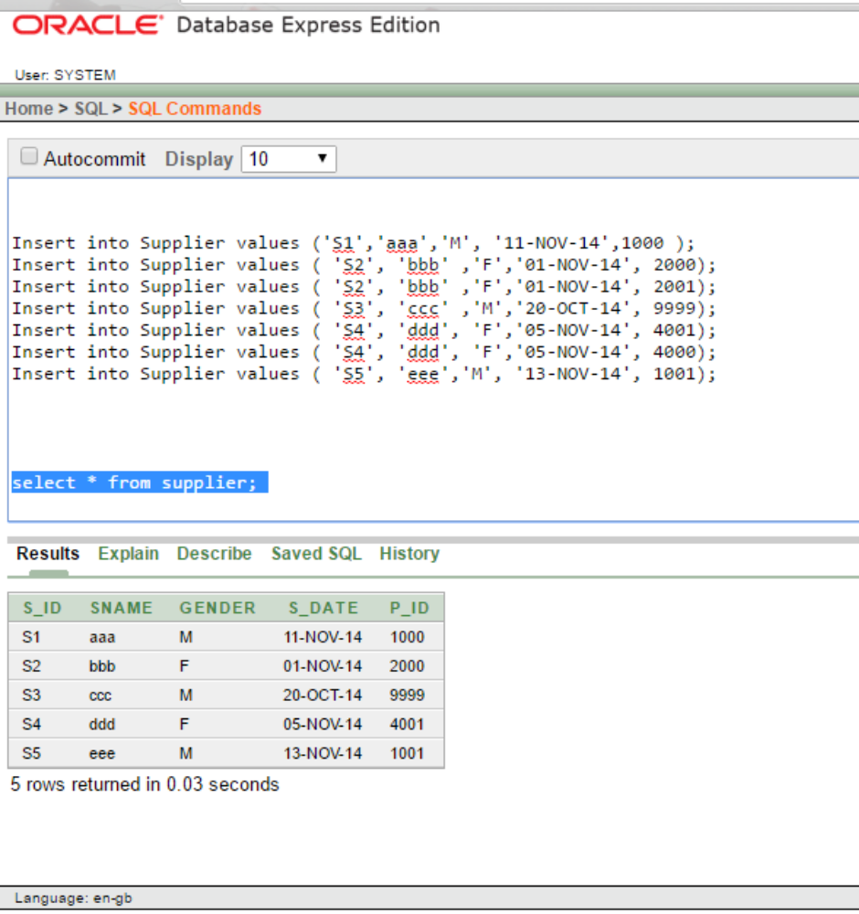

10.Store the data permanently in stable storage
COMMIT;

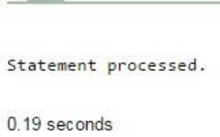

11.Copy the customer table to a new table called ‘customer1’. Rename the new table as customer1.
SELECT * FROM supplier;
CREATE TABLE customer1 AS (SELECT * FROM customer);
SELECT * FROM customer1;
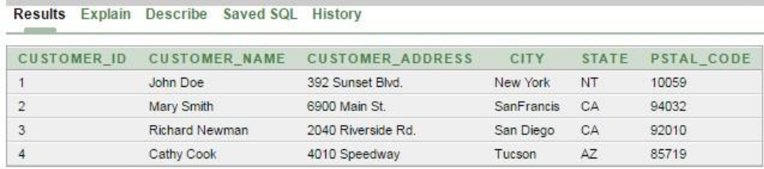

12.Grant select privilege to user1 on Order table
13.Try to insert values into Order table from user1 and state what happen
14.Grant insert privilege on Order table to user1
15.Try to delete values from Order table from user1 and state what happens
16.Try to insert values into Order table from user1 and state what happens.
18 .revoke all privileges from user1 on Order table.
CREATE USER user1 IDENTIFIED BY ab;
GRANT select ON orders TO user1;
GRANT insert ON orders TO user1;
REVOKE ALL ON orders FROM user1;
19.Remove all data’s from the customer1 table.
20.Drop the structure of the customer1 table.
TRUNCATE TABLE customer1;
DROP TABLE customer1;

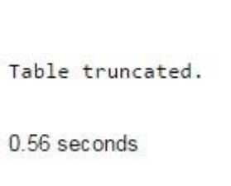
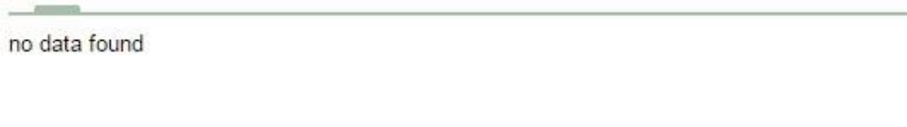
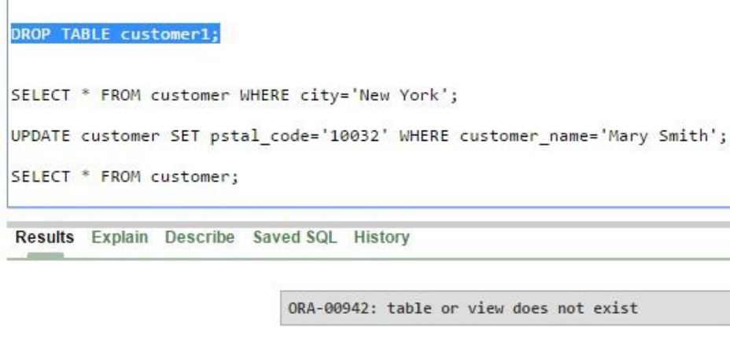

Result:
SQL queries using DDL and DCL commands are successfully executed.

